
RAMAIAH
Institute of Technology
USN | 1 | M | S

(Autonomous Institute, Affiliated to VTU)
(Approved by AICTE, New Delhi & Govt. of Karnataka) Accredited by NBA & NAAC with ‘A’ Grade

MAKEUP EXAMINATIONS – JUNE/JULY 2018

Course & Branch | : | B.E. : Computer Science and Engineering | Semester | : | IV
Subject | : | Design and Analysis of Algorithm | Max. Marks | : | 100
Subject Code | : | CS42/CS1542 | Duration | : | 3 Hrs

Instructions to the Candidates:
- Answer one full question from each unit.

 |  | UNIT- I
1. | a) | Prove that “If f be a polynomial of degree k, in which the coefficient a_{k} is positive. Then f = O(n^{k})” | CO1 | (08)
 | b) | Find the order of growth for the following code snippets using unrolling technique.  - A()  {  int i,j,k,n;  for(i=0;i<=n;i++)  {  for(j=0;j<=i;j++)  {  for(k=1;k<=100;k++)  {  printf(“RIT”);  }  }  }  }  - A()  {  int i,j,k,n;  for(i=0;i<=n;i++)  {  for(j=0;j<=i²;j++)  {  for(k=1;k<=n/2;k++)  {  printf(“RIT”);  }  }  }  } | CO1 | (06)
 | c) | Design Gale Shapley algorithm to determine the stable matching set S for the set of men M and women W. | CO1 | (06)
2. | a) | Prove the transitivity property of asymptotic growth rate.  - If f = O(g) and g = O(h), then f = O(h)  - If f = Ω(g) and g = Ω(h), then f = Ω(h). | CO1 | (06)
 | b) | Define the terms matching, perfect matching, stable matching and best valid partner with respect to gale-shapely algorithm with an example? Consider an execution of the G-S algorithm that returns a set of pairs S for the given set of men M and women W. Prove that “The set S is a stable matching”. | CO1 | (08)
 | c) | Consider the following graph for Competitive Facility Location problem. Given 2 players P1 & P2 with P2 moving first, target bounds 30 & 35 is achievable or not for P1.  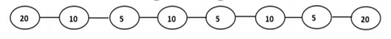 | CO1 | (06)
 |  | UNIT- II
3. | a) | Construct the BFS traversal tree for the following graph.  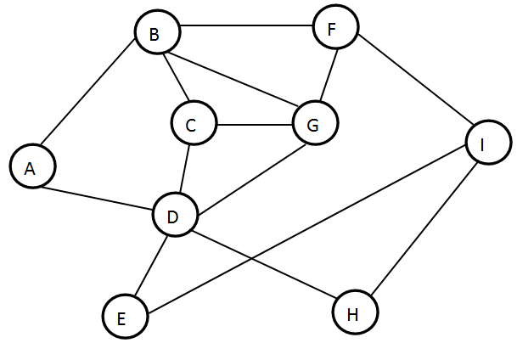 | CO2 | (08)
 | b) | Prove that  “The implementation of the BFS algorithm runs in time O (m + n), if the graph is given by the adjacency list representation.” | CO2 | (04)
 | c) | Design the algorithm for Counting Inversions problem. | CO2 | (08)
4. | a) | Design the recursive version of DFS algorithm. List the differences between DFS & BFS. | CO2 | (06)
 | b) | Discuss the applications of graph traversals for the following:  - Testing Whether a Graph is Bipartite  - Finding Cut-Points in a Graph. | CO2 | (06)
 | c) | Sort the following numbers using divide and conquer method. | CO3 | (08)
  50 | 38 | 40 | 19 | 68 | 70 | 51 | 30 | 12
 |  | UNIT- III
5. | a) | Discuss the interval scheduling algorithm to minimize the maximum lateness. | CO3 | (04)
 | b) | Discuss the single source shortest path problem. Apply the same for the following graph. Take “A” as the source vertex.  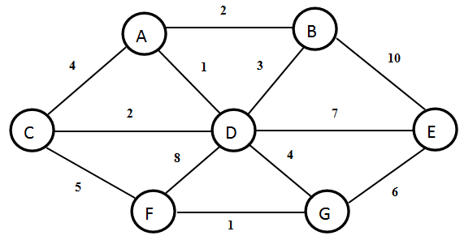 | CO3 | (10)
 | c) | What is Minimum Spanning Tree? Discuss the Kruskal’s Algorithm to find the minimum spanning tree. | CO3 | (06)
6. | a) | Prove that:  “Greedy algorithm for interval scheduling returns an optimal set A”. | CO6 | (06)
 | b) | Discuss Prim’s algorithm to find the minimum spanning tree. Apply the same for the following graph.  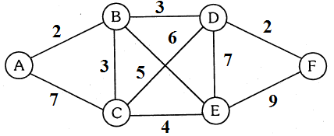 | CO3 | (06)
 | c) | Prove that  “Consider the set S at any point in the Dijkstra algorithm’s execution. For each u ∈ S, the path Pu is a shortest s-u path. | CO6 | (08)
 |  | UNIT- IV
7. | a) | Discuss an algorithm to find the shortest path for a given graph G using Bellman ford algorithm and compute the time complexity for the same. | CO4 | (07)
 | b) | List the intervals that needs to be selected so that maximum weight of the intervals is achieved for the following set of intervals?  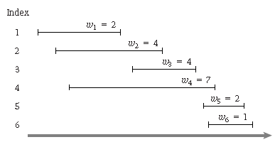 | CO4 | (07)
 | c) | Discuss survey-design problem for a given set of customers and products with an algorithm. | CO4 | (06)
8. | a) | Use Bellman ford algorithm to find the distance from source vertex ‘u’ in a weighted digraph.  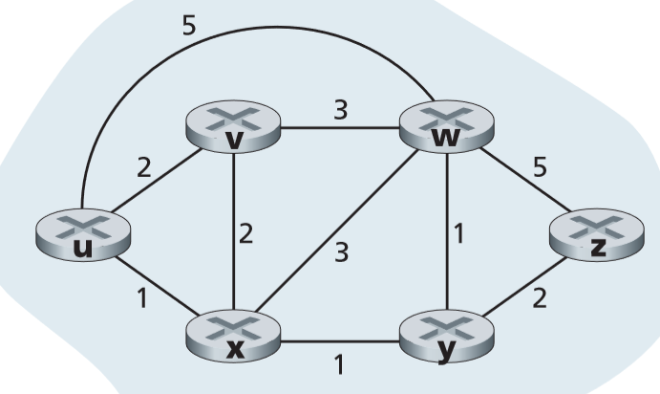 | CO4 | (08)
 | b) | Use Ford Fulkerson algorithm to identify the maximum flow between source vertex 0 and destination vertex 5.  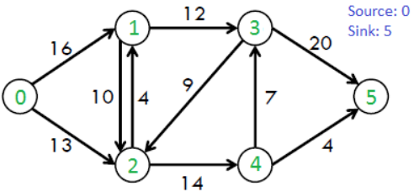 | CO4 | (06)
 | c) | Compute the maximum subset-sum that can be achieved for the following items with maximum capacity W=6. | CO4 | (06)
  Item | Weight
  1 | 5
  2 | 3
  3 | 3
 |  | UNIT- V
9. | a) | Define P, NP, NP-Complete & NP-Hard problems. Give examples. | CO5 | (06)
 | b) | Find all the Hamiltonian Paths in the given graph.  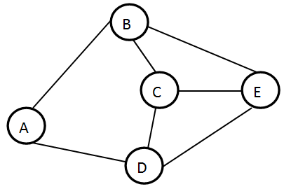 | CO5 | (04)
 | c) | Explain Travelling Salesman problem. Justify whether it is a NP-Complete or not. | CO6 | (10)
10. | a) | Explain the general strategy to prove NP-Complete problems. | CO5 | (06)
 | b) | Prove that Hamiltonian Path is NP-Complete. | CO6 | (06)
 | c) | Explain how Circuit Satisfiability problem is a NP-Complete problem. | CO6 | (08)

****************

